How To Use IBM Aspera to Transfer Files
Note: If you wish to transfer large files (even hundreds of gigabytes), IBM Aspera is a great tool to use. Aspera uploads your files to its server and then emails users to download the files.
Aspera uses a browser plugin so please carefully watch your browser for notifications stating the plugin’s needs to be updated or installed.
Step 1: Visit: https://ibmfaspex.asperasoft.com/aspera/faspex/login/new and either sign in or create a new account using your IBM intranet email address.
Step 2: Click the ‘New Package’ button in the upper left area of your screen
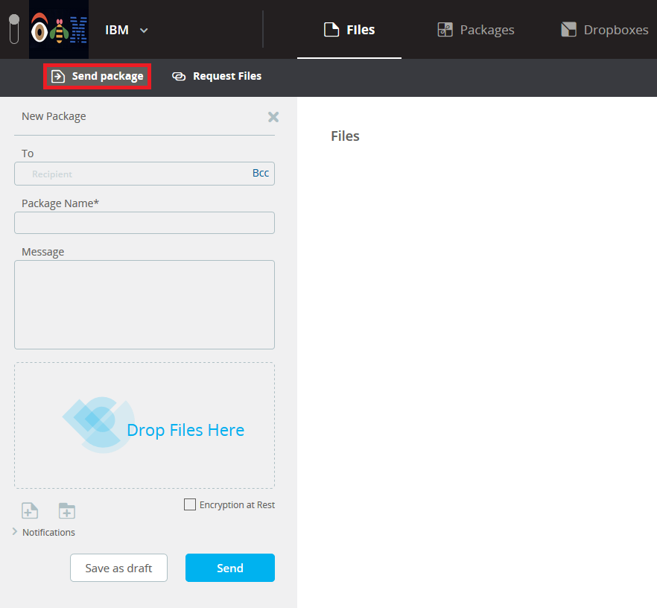
Step 3: Fill in the ‘To’ text box with the email addresses of whom you wish to send the files to. If the recipient is an IBMer, their full name will also appear in this box as you type.
Step 4: Give it a title in the ‘Package Name’ field and feel free to include a message to the recipient.
Step 5: Users can either choose to send individual files/folders from their Aspera account by using the ‘Drop Files Here’ option or browse their local storage using the ‘+’ icons underneath. In addition, there is no file size limit, but you can compress your files using Winrar or 7zip to speed up the download/upload time. Compression can save, on average, about 50% space on a virtual machine which translates into numerous hours saved when downloading/uploading files.
Step 6: Click the ‘Send’ button. Once completed, the files will be downloadable for up to 2 weeks.
Note: If the ‘Send Package’ button is not available, you may need to update or re-install the IBM Aspera plugin. Look carefully at the top of your browser and see if there is an error message stating that the plugin needs to be updated or reinstalled. As for browser compatibility, Google Chrome seems to work more often than Firefox so it would be wise to try both. Lastly, if you require additional help, please contact IBM Aspera directly.

